

School of Engineering and Technology


Introduction to Linux Bash Scripting
Lab File

ENCS356
for
B.Tech. CSE (Cyber Security)
(2025–2026)

Submitted By:
Khushi Sharma
LIST OF EXPERIMENTS
Experiment 1 1
Installation of Linux OS (VirtualBox + OVA File) 1
Experiment 2 6
Exploring System Commands and Run Levels
Experiment 3 10
Working with Files & Directories
Experiment 4 15
Deleting, Copying, Moving, and Renaming Files
Experiment 5 19
Searching for Files using grep, fgrep
Experiment 6 24
Understanding Preamble, Virtual Terminals, Display Manager

Experiment 7  Managing Users and Groups | 29
Experiment 8 | 34
Linux Package Management using rpm & yum
Experiment 9 39
Mounting and Unmounting Devices
Experiment 10 44
Understanding Shell Types & Basic Scripts

Experiment 11 49
Commands related to inode, redirection, piping, process control

Experiment 12  Shell Programming: Interactive scripts, parameters, arithmetic | 54
Experiment 13  File creation and manipulation script | 60
Experiment 14  Script: user count, listing files, job control | 64
Experiment 15  Script: Change date format | 68
Experiment 16  Script: Print file names with metadata | 72
Experiment 17 | 76
Script: Count lines, words, characters (without wc)

Experiment 18  Script: Print glossary in reverse using array | 80
Experiment 19  Script: Repeated login check (every 30 sec) | 84
Experiment 20  Script: Compute GCD & LCM | 88
Experiment 21  Script: Prime number detection | 93
Experiment 22  Mini Project: Network scanning script using Nmap | 98
Experiment 23
Mini Project: Text-based Bash game

Experiment 24
Mini Project: Backup automation script



Efficient use of the Linux operating system requires a strong understanding of basic system commands, system states, and built-in help mechanisms. Unlike graphical operating systems, Linux relies heavily on command-line utilities for system interaction, administration, and automation.
The problem is to explore and practice essential Linux system commands, understand system run levels / targets, and effectively use Linux help utilities such as man, --help, and autocompletion to access command documentation and usage information.

Theory

Linux Command Line Interface (CLI)
The Linux CLI allows users to interact with the operating system by typing commands. It provides precise control over system operations and is faster and more powerful than graphical interfaces for many tasks.

System Run Levels / Targets
In modern Linux distributions using systemd, run levels are replaced by targets, which define the system’s operating state.
Common targets:
- graphical.target – Multi-user mode with GUI
- multi-user.target – Multi-user mode without GUI
- rescue.target – Single-user rescue mode
- poweroff.target – Shutdown system
- reboot.target – Reboot system

Procedure
- Log in to the Linux virtual machine.
- Open the Terminal.
- Execute basic system commands:

Commands Used
pwd | Display current working directory
ls | List files and directories
cd | Change directory
whoami | Display current user
date | Show system date and time
uptime | Show system running time
man | Display manual pages
--help | Display command help
systemctl | Manage system services and targets
runlevel | Display previous and current run level
clear | Clear terminal screen

1.pwd, ls, whoami, date, uptime
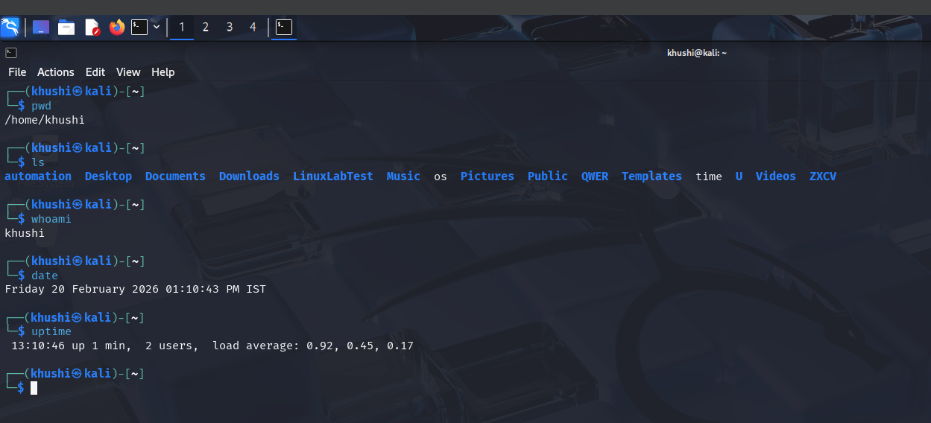

2. ls --help
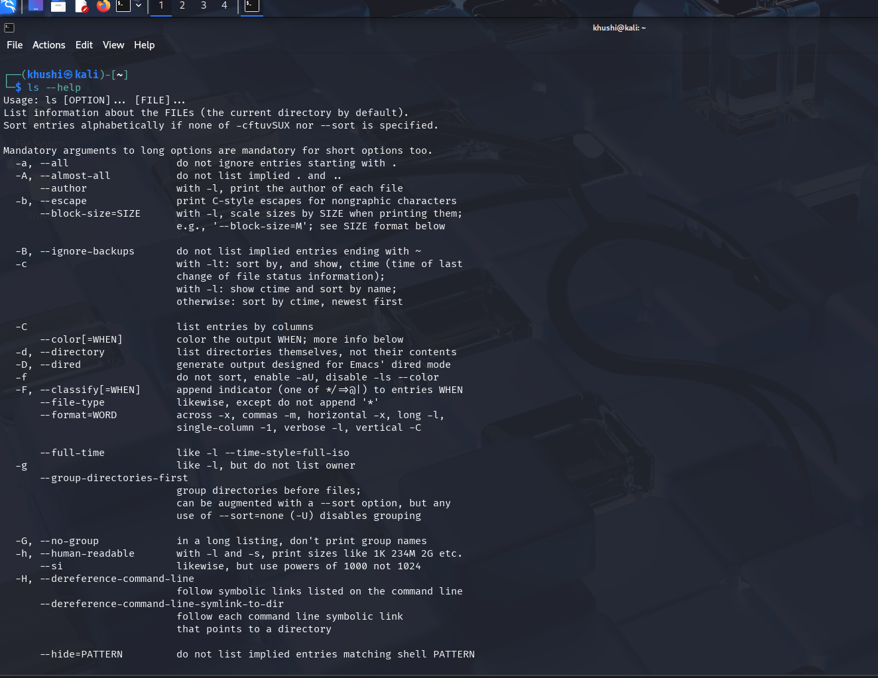
3. man

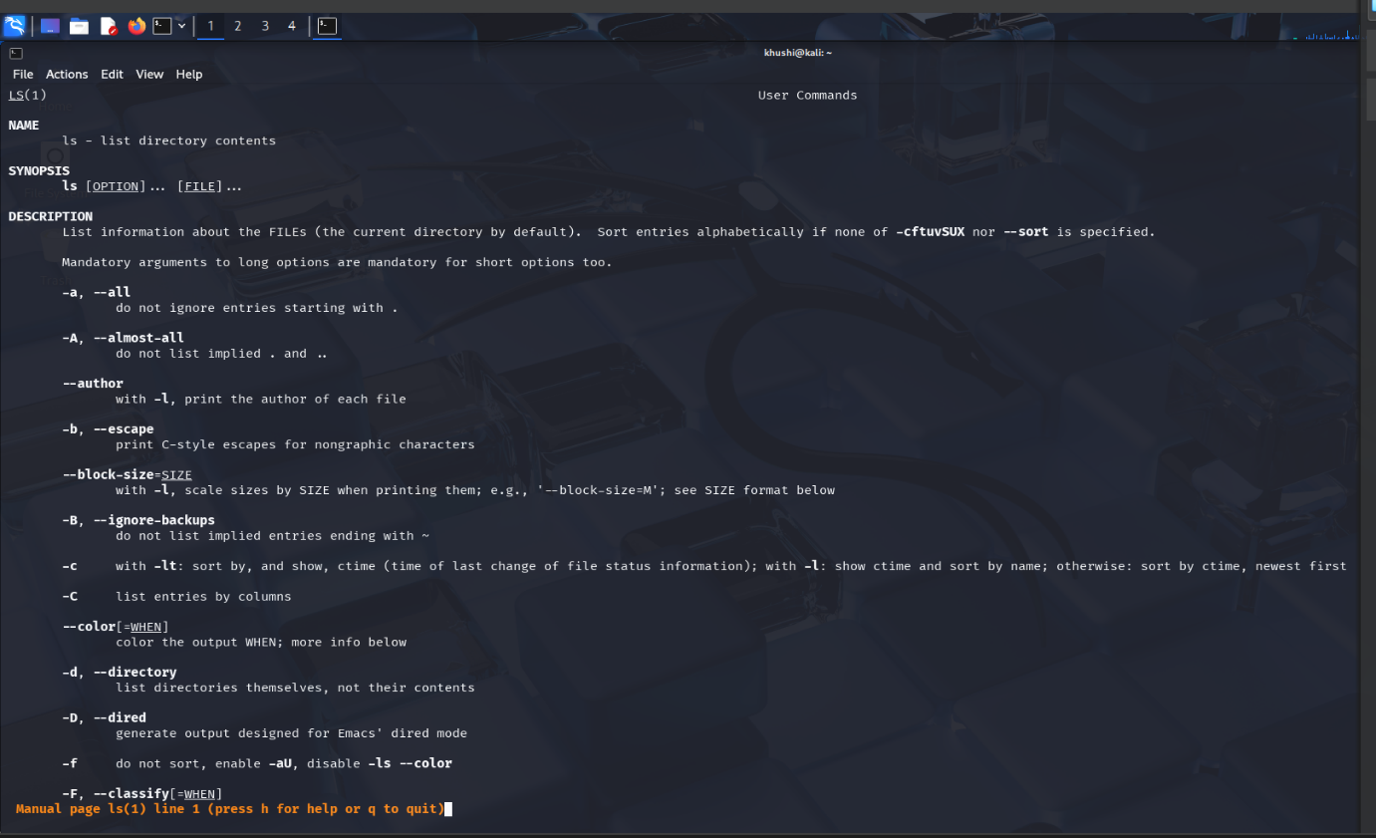
4. ls –help systemctl
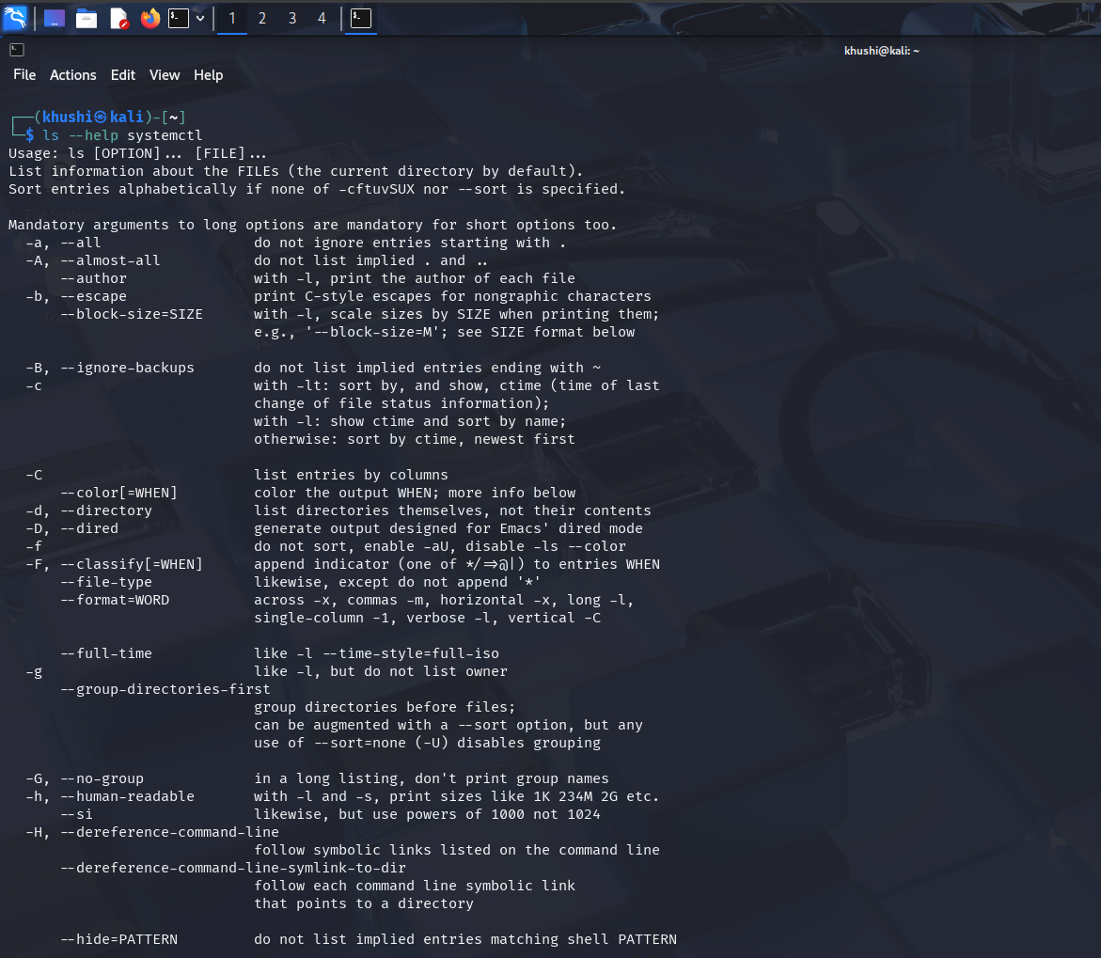

Result
Basic Linux system commands, run levels, and help utilities were successfully explored and executed. The student gained practical understanding of Linux command-line interaction and documentation mechanisms.

